

Name: Jaswaanth Narayanasamy

Module: Software Development (HTML)

Title of The Website: GreenBite

Contents

Introduction 3

Wireframes 4

HTMl Validity Testing 10

(W3C Markup Validation) 10

CSS Validity Testing 12

(W3C CSS Validator) 12

Accessibility Testing 12

# Introduction

The purpose of this report is to demonstrate the comprehensive processes of design, development, and testing of a website called GreenBite wellness, which served as the final and culminating project for the COMP40053 module. The primary aim was to create a “working” multi-level website with several pages while using the core basic website development tools: HTML, CSS, and JavaScript, and doing so without external frameworks or I Libraries. The project started with the description and analyzing the brief to subdivide the necessary features (the calorie counter, exercise recipe filter, and workout generator) into achievable development steps. I started by designing rough page arrangement wireframes to map user flow before the actual coding process, and prioritized mobile first to broaden accessibility. The development of the site came with a load of obstacles, particularly with the interactive JavaScript elements to which the solution came from trial and error, research documentation and trial and error debugging with the console. The design was done with a custom CSS file, that allowed for a more unique style for all pages. Rigorous testing for accessibility, validity and performance was done before finalizing the website and deploying it to GitHub Pages.

This is my website link: https://jaswaanth7835-gif.github.io/greenbite/

# Wireframes

|  |  |  |  |  |  |
| --- | --- | --- | --- | --- | --- |
| HOME | HEALTHY RECIPE | CALORIE CALCULATOR | WORKOUT GENERATOR | MINDFULNESS | CONTACT |

**HEALTH TIP**

**HERO SECTION**

CALORIE CALCULATOR

MINDFULLNESS

WORKOUT PLAN

HEALTH RECIPE

TEXT

TEXT

TEXT

LINK

LINK

LINK

LINK

TEXT

BUTTON

BUTTON

BUTTON

BUTTON

TEXT

INPUT

BUTTON

|  |  |  |  |  |  |
| --- | --- | --- | --- | --- | --- |
| HOME | HEALTHY RECIPE | CALORIE CALCULATOR | WORKOUT GENERATOR | MINDFULNESS | CONTACT |

**HEADING**

SEARCH

BUTTON

BUTTON

BUTTON

BUTTON

TEXT

TEXT

TEXT

LINK

LINK

LINK

LINK

TEXT

BUTTON

BUTTON

BUTTON

BUTTON

TEXT

INPUT

BUTTON

BUTTON

TEXT

BUTTON

TEXT

BUTTON

TEXT

BUTTON

TEXT

BUTTON

TEXT

BUTTON

TEXT

BUTTON

TEXT

BUTTON

TEXT

|  |  |  |  |  |  |
| --- | --- | --- | --- | --- | --- |
| HOME | HEALTHY RECIPE | CALORIE CALCULATOR | WORKOUT GENERATOR | MINDFULNESS | CONTACT |

**BUTTON **

**OPTION(AGE) **

**INPUT(AGE)**

**INPUT(AGE)**

**OPTION(AGE)**

TEXT

TEXT

TEXT

LINK

LINK

LINK

LINK

TEXT

BUTTON

BUTTON

BUTTON

BUTTON

TEXT

INPUT

BUTTON

**HEADING**

**INPUT(AGE)**

TEXT TEXT

**BUTTON **

**TEXT**

**TEXT**

**TEXT**

**TEXT**

|  |  |  |  |  |  |
| --- | --- | --- | --- | --- | --- |
| HOME | HEALTHY RECIPE | CALORIE CALCULATOR | WORKOUT GENERATOR | MINDFULNESS | CONTACT |

**INPUT(AGE)**

**INPUT(AGE)**

**BUTTON **

TEXT

TEXT

TEXT

LINK

LINK

LINK

LINK

TEXT

BUTTON

BUTTON

BUTTON

BUTTON

TEXT

INPUT

BUTTON

**HEADING**

**BUTTON **

TIMER

**BUTTON **

**BUTTON **

|  |  |  |  |  |  |
| --- | --- | --- | --- | --- | --- |
| HOME | HEALTHY RECIPE | CALORIE CALCULATOR | WORKOUT GENERATOR | MINDFULNESS | CONTACT |

TEXT

TEXT

TEXT

LINK

LINK

LINK

LINK

TEXT

BUTTON

BUTTON

BUTTON

BUTTON

TEXT

INPUT

BUTTON

**BUTTON **

**BUTTON **

**BUTTON **

**BUTTON **

**TEXT**

**BUTTON **

**BUTTON **

**BUTTON **

**BUTTON **

**BUTTON **

**BUTTON **

**BUTTON **

**TIMER**

**TEXT**

**BUTTON **

**BUTTON **

**ANIMATION**

**TEXT**

**HEADING**

**TEXT**

|  |  |  |  |  |  |
| --- | --- | --- | --- | --- | --- |
| HOME | HEALTHY RECIPE | CALORIE CALCULATOR | WORKOUT GENERATOR | MINDFULNESS | CONTACT |

**INPUT(AGE)**

**TEXT**

TEXT

TEXT

TEXT

LINK

LINK

LINK

LINK

TEXT

BUTTON

BUTTON

BUTTON

BUTTON

TEXT

INPUT

BUTTON

**HEADING**

**INPUT(AGE)**

**INPUT(AGE)**

**TEXT**

**BUTTON **

**TEXT**

**TEXT**

**TEXT**

**TEXT**

# HTMl Validity Testing

## (W3C Markup Validation)

Home

Recipe

Calculator

Contact us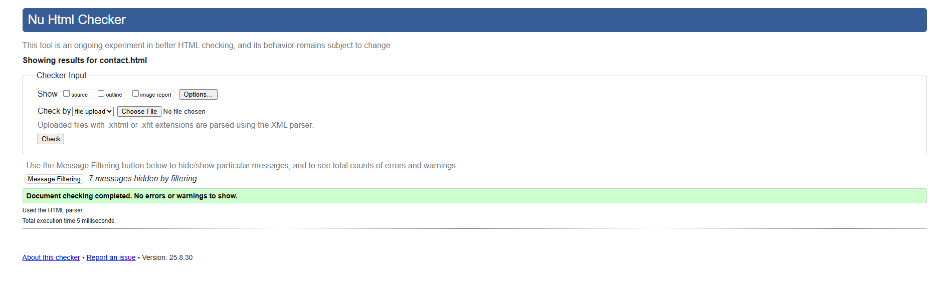

# CSS Validity Testing

## (W3C CSS Validator)

# Accessibility Testing

## (WAVE Web Accessibility Evaluation Tool)

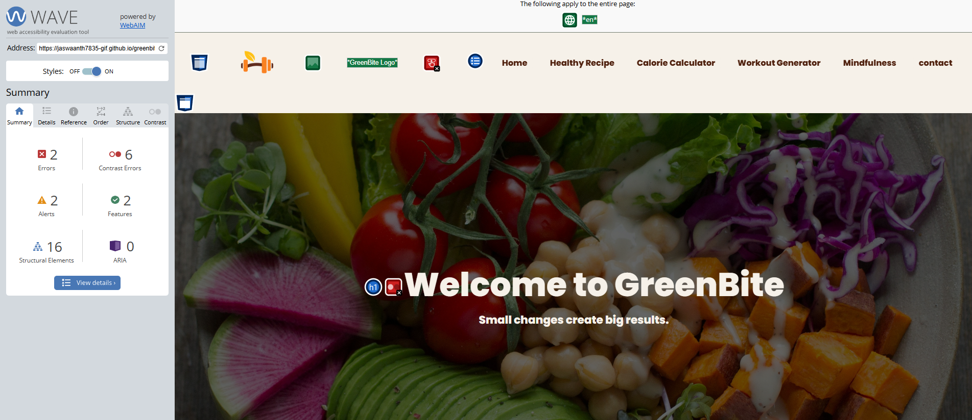

# Lighthouse testing

## MOBILE- Chrome DevTools

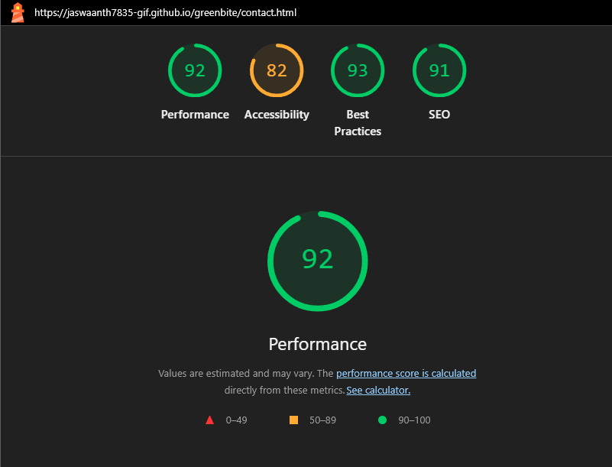

## Desktop - Chrome DevTools

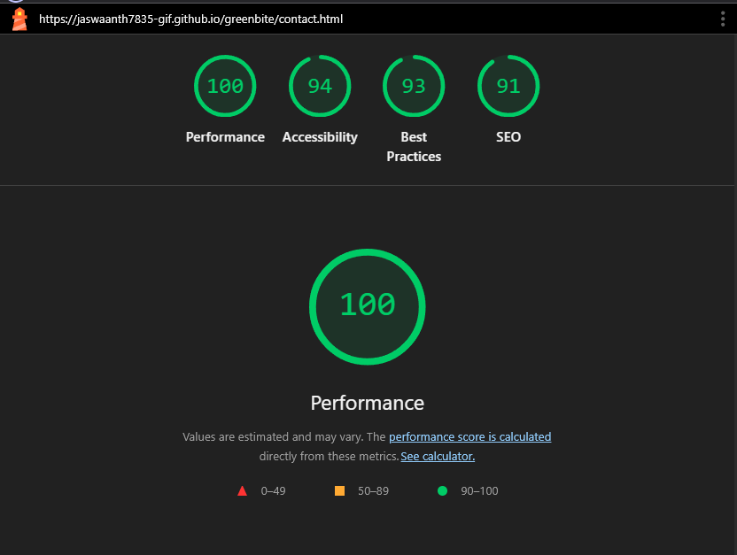

# Responsive Testing

## Desktop

## Mobile